Q1. Koforidua tech well is an it company based in koforidua in the eastern region of Ghana Established in the year 2000.

The company utilizes a project organizational structure due to the many projects it undertake. The company recently finalized a new deal with the development of a new car control software for a company located in Amsterdam in Netherlands. The company is searching for a new project manager to lead this project. The new manager must understand and be able to work in a project organisation setup. The new manager need to understand and be able to take advantage of the opportunity and challenges that exist in project organisations that have the potential of affecting the success of IT project.

You have been employed as the project manager for the car control software. Required

As the project manager

1. **Using the appropriate diagram discribe a project organisation and how it can be applied.**

**Matrix organizational structure**

**Project Coordinator**

**Accountant/ Administration**

**Training Coordinator**

**Provincial Coordinator**

**Provincial Coordinator**

**Field Coordinator**

**Field Coordinator**

**Field Coordinator**

**Field Coordinator**

Project organization is a structure that facilitates the coordination and implementation of project activities. The structure determine the authorities, role, responsibilities, communication channel and the availability of resources to be used by the organisztion. One of the project organization is Matrix.

1. The matrix organization is the combination of the vertical functional structure and horizontal project structure. the matrix organizational structure may work best when an organization takes on project that require a cross-functional approch.
2. **what opportunities and challenges are you likely to experience in the project plan and execution**

Baseline plan which is agreed upon scope, schedule and budget used to mearsure project performance for developeding the planning stages. And the challenge are Immproper communication, scope creept , time to complete the project.

1. **what qualities are required of a suitable project manager for a project of this nature**
2. The ability to communicate with people: a project manager must have strong communication skills. A project manager must have the ability to connect with people, share a common vision, and get everyone respond or head in the right direction.
3. The ability to deal with people: a project manager must have the skill for dealing wth people, their egos, and their agendas. The project manager must be good listener, hearing what people say and understaning what they mean.
4. The ability to create and sustain relationship: project manager must be build bridges instead of walls. Acting as a peacemaker or negotiator among the client or sponsor, top management, the project team, customer, supplier, vendors, subconductor and so fort may be necessory.
5. The ability to organize: a project manager must be good at organizing project plan, acquiring resources and creating in effective project environment. The project manager must also know and understand both the details and the big picture which requires a familiarity with the details of the project plan and also an understanding of how contingencies may impact the plan.
6. **will a work group or a real team be more suited for this project? Explain your answer.**

YES, because work group is base on the traditional approch where a single leader is in control, makes most of the decissions, delegates to subordinates and monitor the progress of the assigned tasks. The perofamce of a working group depends greatly on the leader. Also the realteam is consists of a small number of people with complimentary skills who are committed to a common purpose, performance goals, and approch for which they hold themself mutually accountable.

Q2. Chen Technologies is planning to develop a new software that automates the production of new smart phones. An IT project methodology is needed to guide the planning, implementation and deployment of this software. As the project manager for this new assignment, you have found it necessary to explain to management aspects of the project you realise will require the dedication and commitment of management. Required

1. **Using a diagram, illustrate the phase in IT project methodology for management understanding and appreciation of the proposed project.**

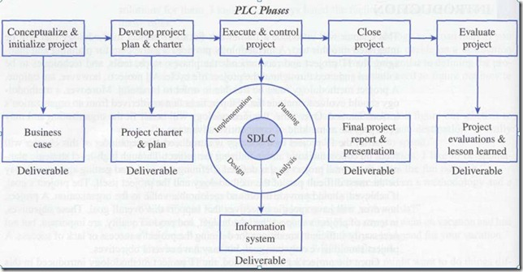

The figure show the phase of IT develpoment life cycle.

A methodology provides a strategic-level plan for managing and controlling IT ptojects. It sevice as a templete for initiating, planning and developing an information system. It can be noted that difference is information systems may be in the product and not necessarlly the process of manageing the project and thus the methodology recommends the phase, deliverables process, tools and knowledge areas for supporting it ptoject.

**b. Help management understand what project Infrastructure is and how it support IT**

Projct infrastucture is the people, resouecs, technology, methods, project management processes, that are required to support the project. The project infrastructures are:

1. Organizational infrastucture is how project are supported and managed within the organization.
2. Project infrastucture support the project team of the project environment.
3. Technical infrastructure provides the haredware and software tool to support the project team. This may include such things as project management software, e-mail, voice mail, word processing, access to the internet.

Q3. The android limited is a company that is heavily involved in IT systems development, over the years, their experiences have thought them to creticaly conceder the potential risk that can affect their project out come. As the project manager, you required two new employees to take charge of identified project ......due to the potential of limited experiences of this new members, you will need to provide training to enable them meet the demands of the new project.

Required.

**What is project riks**. is a uncertian event or conditon that if it occurs has negative or positive effect on the project objective.

1. **You are to explain to these members what project risk management is?**

Project risk management is the systemmatic process of identitifying, analyzing, and responding to project risk. It includes maximizing the probability and co sequences of positive events minimizing the probability and consequences of adverse event.n

1. **provide a brief description of what is required for effective and successful management of project risk.**

Effective and successful project risk management require:

1. Commitment by all stakeholder thus the project sponsor or client, senior management, the project manager, and the project team must all be committed.
2. Stakeholder resopnsibility to monitor the project in order to identify any new or increasing risks and who will make regular reports to the project sponsor or client.

1. **explain to them the seven IT project risk management and how to apply them.**
2. Risk planning requires two critical action that is a firm commitment and prepration to the entire risk management approach from all project stakeholders.
3. Risk identification implies determining and understanding the ture cases and effect of each risk.
4. Risk assessment is the basis for understaning how to deal with project risks. Thus a bqualitative and quantitave approch canbe used to assist the risk.
5. Risk stratageis detemine how to deal withthe various project risk that is an approch stratages needs to be takenon aparticular risk. These stratage can be accept or ignore the risk, avoidthe risk completely, reduce the likehood or impact of the risk if the risk occurs.
6. Risk monitoring and contorl implise scanning the project environment for both identity and unidentity threat and opportunities so that well information decisions and appropraite action can be taken.
7. Risk response is the risk owner should commit resourec and take actions once a threat or opportunity is made k nown through the risks monitoring and control phase.
8. Risk evaluation comes in a form of formal and documented evaluation of a risk incidence which provide the basis for lession learn and lays of foundation for identify the best practies.

Q4. Telco an IT company is about to embark on a major technology project. They have been informed that to be successful in a project of these nature,the need intensive planning and integration of the various aspects of the project. The management of the organisation has been advised to request for a project channel which deals with everything about the project.

Required. Using an appropriate diagram

1. **Describe project integration and it relationship to the other project object management body of knowledge.**

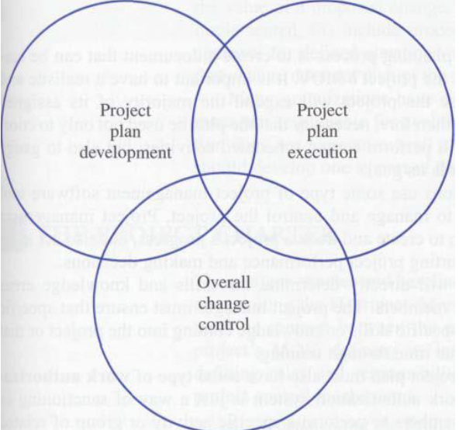

The three componet of project integration .

Project integration is the collectiuon of process require to insure that the vararious element of the project are porperly coordinated. It involves making trade off among competing object and alternatives to meet or exceed stakeholders needs and expectation. The process involved integration management are:

1. Development project charter
2. Developing project management plan
3. Directcting and managing project work
4. Performing integrated change change control
5. Closing project or phase

1. **explain a project charter and it usefulness as a communication tool**.

A project charter is the agreement between the project sponsor and the project team. It provide the following information about the project; documents the project mearsurable oragnizational value defines the project infrastucture thus defines all of people, resourec, technology tha are require to suport the project, summarizes te details of the project plan, show explicit commitment to the project and also set out project control mechanism. The project charter identifies the project sponsor, project manager, project team, and when and how they will be involved througout the project life cycle.

**The five phases of project management include conception and**

**initiation**

**planning**

**execution**

performance/**monitoring**

project closure.